

**IT1060 – Software Process Modeling May-2023**

# Assignment 2 Cover Sheet

|  |  |
| --- | --- |
| **CASE STUDY NAME** | Sign Up |
| **PROJECT ID** |  |

**Group Details:**

|  |  |  |
| --- | --- | --- |
|  | **Student Registration Number** | **Student Name** |
| **1** |  |  |
| **2** |  |  |
| **3** |  |  |
| **4** |  |  |
| **5** |  |  |

**IT1060 – Software Process Modeling**

# Assignment 2 Certify Sheet

|  |
| --- |
| **Checkmark with solid fill**I hereby certify,  **Checkmark with solid fill** The attached is my own work and no further changes will be made.  I have contributed in this assignment to the best of my ability.  And I understand,  **Checkmark with solid fill**I may be subject to student discipline processes in the event of an act of academic misconduct by me including an act of plagiarism or cheating. |

**Student Details:**

|  |  |  |  |
| --- | --- | --- | --- |
|  | **Student Registration** |  |  |
| **Student Name** | **Number** | **Date** | **Signature** |
| Liyanage N S | IT22144430 | 29/05/2023 |  |

**Part I**

1. **Use Case Scenario**

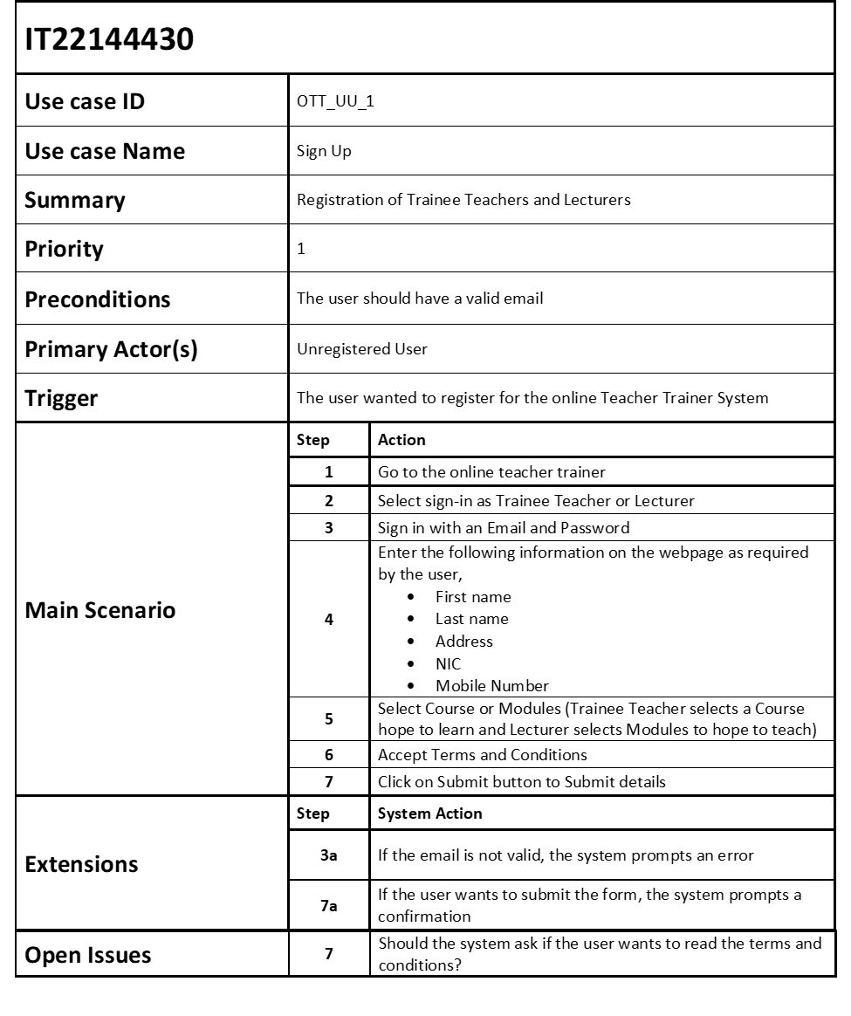

1. **Activity Diagram – Without Partition**

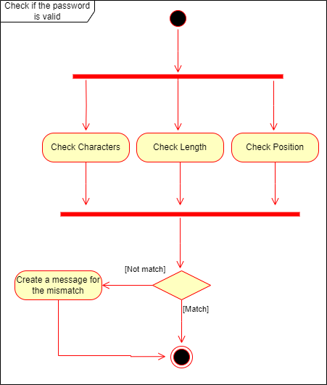

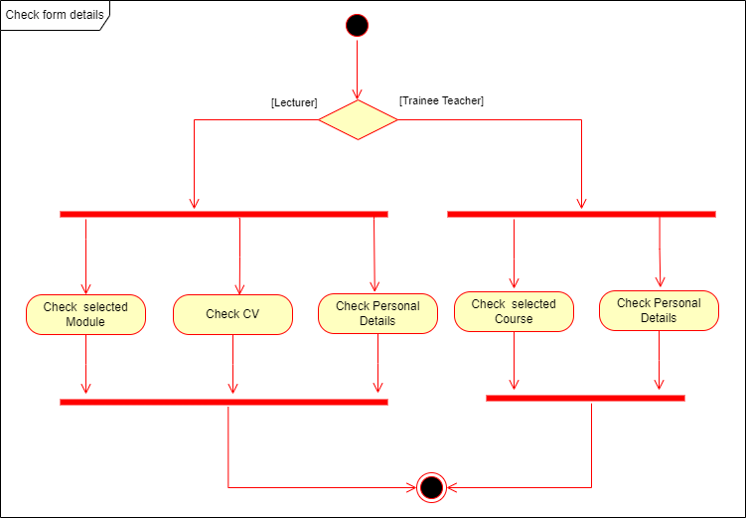

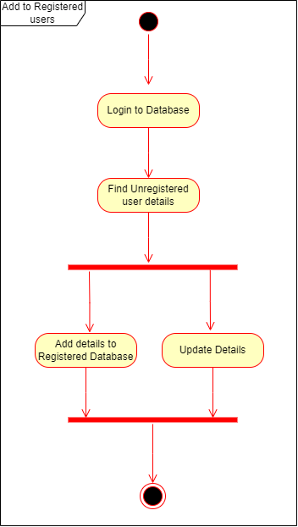

**Part II**

1. **Sub Systems**

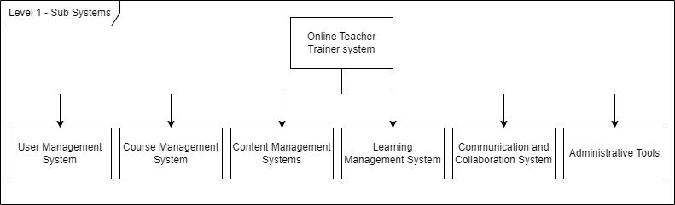

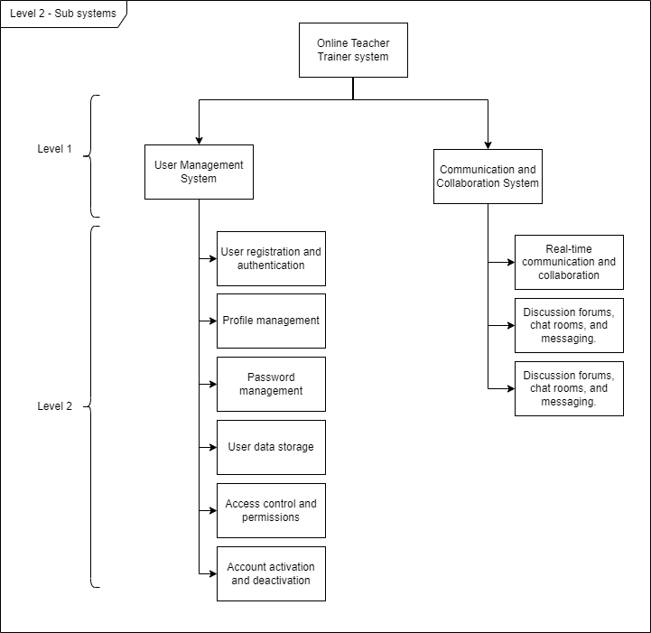

1. **Activity Diagram with Partition**

